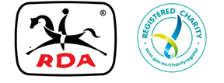

**MEMO**

**TO: Centre Committees**

**FROM: Jan Pike, Executive Officer**

**DATE: Friday 1st November, 2019**

**RE:** **Annual Report**

 Hello Everyone,

As we draw towards the end of 2019 and we all prepare for a well deserved break, I just need to remind Centres to send their Annual Report for 2019.

We all know how much photos can say about the great work done at our RDA Centres, so please include heaps with your Report.

Please check the specifications for photos in the RAM and the email sent out from State Office recently.

This year we’re hoping to produce an even better version of our Annual Report so don’t let your Centre not be represented.

Also it’s time to consider those amazing horses, volunteers and riders who deserve recognition. Imagine holding the State trophy for excellence in one of these categories. If you want to have a chat about nominating please don’t hesitate to contact me. I know many Centres have their own awards which are very significant, however winning a State Award is important for the organisation as well as acknowledging your Centre’s hard workers.



Till next time!

 Jan Pike