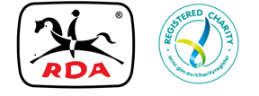

**MEMO**

**TO: Centres, Regional Representatives**

**FROM: Executive Officer**

**DATE: Thursday, 21st November,2019**

**RE: State Awards**

**Hello Everyone,**

**The Board has just been made aware of an incorrect addition to the State Awards information. There is absolutely no expectation that an Award Winner must attend the Annual General Meeting to receive their Award. It would be preferable if they or a representative could attend the presentation, however this is certainly not a requirement.**

**Award Winners are reimbursed travel, meals and accommodation costs as a mark of respect from the Board of Directors. If this has been deterring Centres from nominating their very worthy nominees, then I can assure you it is no longer applicable and all documents relating to State Awards will be changed to avoid confusion**

**Please thank your volunteers, horses and riders by giving them this opportunity to be acknowledged State wide..**

**Kind regards,**