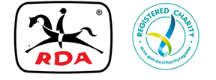

**MEMO**

**TO: RDA(NSW) Centres**

**FROM: Executive Officer**

**DATE: Tuesday, 28th January, 2020**

**RE: Various**

**Hi All,**

**Happy New Year to everyone, hoping you’re all refreshed and ready for another successful year of RDA(NSW) activities and adventures. Firstly, on behalf of the Board, may I commend each and every one of you for your fortitude, courage and consideration towards each other during the recent horrific circumstances that have befallen our State.**

**The Board would like to send out congratulatory letters to anyone within RDANSW announced in the Australia Day or Queens Birthday awards. Whilst I’ll be checking the extensive lists, so I don’t inadvertently miss anyone, I’d appreciate Centres sending notification to State Office of any recipients.**

**As the Annual Report is currently being designed it is imperative that Centres send:**

1. **The Centre Annual Report (HR photos included)**
2. **Vales for horses and volunteers**

**Thank you all for your contribution to making RDA(NSW) such a wonderful organisation.**

**Kind regards,**