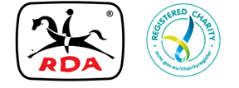

**MEMO**

**TO:Centres, CASP, SNC**

**FROM: Executive Officer**

**DATE: Monday 16th, 2020**

**RE:** STATE Workshop

Hi Everyone ,

The Board of Directors in consultation with CASP and Central Coast RDA has decided that in the interest of public safety for our volunteers during the COVID-19 health precautions, that the 2020 Coaching Workshop will be cancelled for the first weekend in May.

The Board is currently liaising with ASIC regarding the AGM and we will advise members as soon as possible.

We have taken advice from the various agencies involved in the management of this pandemic and feel this is the most appropriate and responsible action to be taken . We apologise for any inconvenience this may cause .

Kind regards,