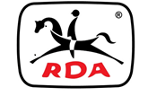
MEMO
TO: Centre Committee Members
FROM: Executive Officer
DATE: Monday, 4th May,2020
RE: Committee Minutes and Financial Reports

Dear Committee Members,
The RDA(NSW) Board of Directors would like to ask Centre Secretaries to please ensure that the Centre’s name is always on the minutes and financial reports sent to State Office .
This makes it much easier for the Office Coordinator and the Directors to establish which Centre we are reading about.
The Board would also like to stress the importance of Centres sending copies of the Minutes of Committee Meetings along with up to date financial reports as soon as possible following meetings.

Kind regards,

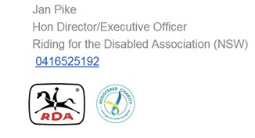
Kind regards,

