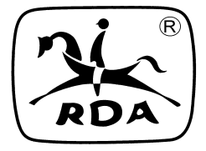
Riding for the Disabled Association (NSW

2023 ANNUAL GENERAL MEETING

SATURDAY 6 May, 2023
hosted by

Proposed Program
When: Sat 6 May, 2023

Where: Grand Ballroom
Rydges Norwest, Sydney
1 Columbia Court
Baulkham Hills

Programme:
5.15pm Registration for Annual General Meeting

5.50pm Welcome/ Official Opening by - TBA
Banner Parade

6.00pm Annual General Meeting

7.30pm Dinner included through the night:
STATE Award Presentations:
- Pearl Batchelor Volunteer of the Year Award
- Young Volunteer of the Year Award
- Rider of the Year Award
- Volunteer Encouragement Award
- Shush Memorial Award

      - Drawing Competition winners
      - Announcement of Popular Choice Photo

Enjoy the rest of the evening

