Riding for the Disabled Association (NSW)

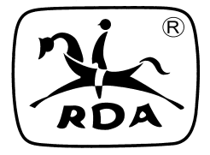

**2023 Annual General Meeting**

**Saturday 06 May, 2023**

**MEMORANUM**

|  |  |  |
| --- | --- | --- |
| **TO:** | Board of Directors Regional Representatives  CASP | RDA Centres Life Members |
| **FROM:** | **RDA(NSW)** |  |

The (RDA) AGM/Administration Workshop will be held on 6 May, 2023.

PLEASE NOTE: Administration Workshop being hosted by RDA (NSW) – Administration Program with some Coaching content will be sent to Centres shortly.

Enclosed are the following: -

* Program for AGM/Dinner
* Accommodation Information Sheet
* Registration Form

# Please complete and return:

* + Registration form along with payment by

23 April 2023.

* + Check Registration Form carefully that you have noted your attendance and enclosed payment for the AGM Dinner as numbers are limited.

## Olwen Smith

*Hon. Director EO/MPIO*