**Saturday, March 23, 2024**



Address: PO Box 710 Sydney Markets NSW 2129; Phone: 02 8736 1256

Office Location: Quad 1, Level 2, 8 Parkview Drive, Sydney Olympic Park, NSW 2127 Email: [stateoffice@rdansw.org.au](mailto:stateoffice@rdansw.org.au) Website: [www.rdansw.org.au](http://www.rdansw.org.au/)

**Dear Centre Secretaries,**

**Firstly may I sincerely o**ﬀ**er our apologies for the delay in sending you a letter explaining what is happening with the funds received from the Golden Eagle Race in 2023.**

**Directors of the Board were divided and at an impasse as to how this windfall could be distributed. The majority believed that it was intended to be used to benefit our Centres throughout the State. Others, however are of the opinion that the funds should only be used for State based projects or activities. In an attempt to resolve this impasse the board sought legal advice to interpret the State Constitution particularly Clauses 6.2/6.5 and 3.1(c).**

**The response from our Solicitors is attached for your reference. The Board then voted on a NOM to distribute funds in accordance with the intent of the donation and the Objects of RDA(NSW) as outlined in Clause 3.1. This NOM is also attached for your reference. This motion was carried with a majority of 4 to 2 and recorded at State O**ﬃ**ce.**

**The conclusion by a majority of Directors is that Centres may apply for grants as per Clause 3.1 of the State Constitution . There are guidelines and each application must be approved by the Board. The guidelines are also attached.**

**For and on behalf of,**

**Jan Pike, Tracy Lucas, Clarry Quirk, Allan Burton**



Address: PO Box 710 Sydney Markets NSW 2129; Phone: 02 8736 1256

Office Location: Quad 1, Level 2, 8 Parkview Drive, Sydney Olympic Park, NSW 2127 Email: [stateoffice@rdansw.org.au](mailto:stateoffice@rdansw.org.au) Website: [www.rdansw.org.au](http://www.rdansw.org.au/)



Centre Details:

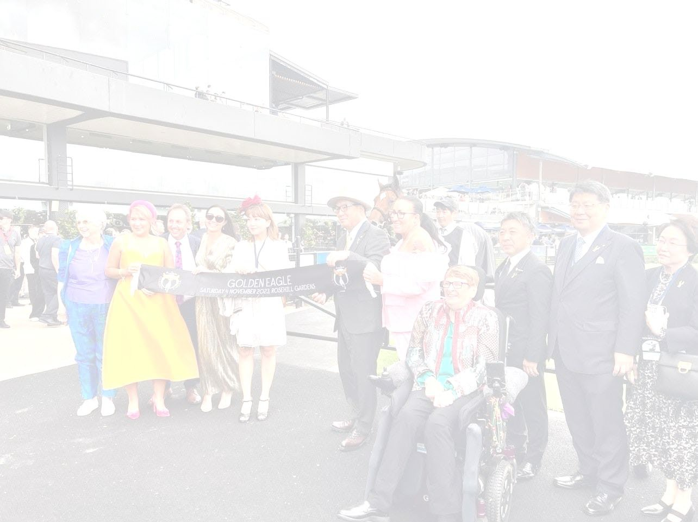Name of Organization: Riding for the Disabled Association (NSW) – 50 001 823 267 Address:

Contact Person:

Contact Information:

**Project Title:**

Project Summary:

We are excited to apply for the grant opportunity provided by RDA (NSW) to enhance our services at our [ ] in New South Wales. With the support of this grant, we aim to allocate $15,000 towards improving our facilities, benefiting our volunteers, participants, families, and horses.

Project Description:

Our [ ] has been serving the community for [ years] by providing therapeutic horse riding programs for individuals with disabilities. We believe that the grant of

$15,000 will significantly enhance our services and make a positive impact on the lives of our participants and their families.

Guidelines to Utilize the Grant:

1. Facility Upgrades: We plan to allocate a portion of the funds towards improving our facilities to

create a safer and more accessible environment for our participants.

1. Volunteer Training and Support: We will use a portion of the grant to provide training opportunities for our volunteers to enhance their skills and knowledge in working with individuals with disabilities.
2. Participant Scholarships: A portion of the funds will be used to provide scholarships for participants who may not have the financial means to participate in our programs.
3. Equine Care: We will allocate funds towards the care and well-being of our therapy horses to ensure they are healthy and able to continue providing therapeutic benefits to our participants.

Founded: 1972 by Pearl Batchelor OAM. Joint Patrons: Her Excellency The Honourable Margaret Beazley AC KC, Governor of NSW and Mr Dennis Wilson ABN 50 001 823 267 • CFN 12295 Charitable Fundraising Act 1991 **All donations $2 or more are tax deductible**

*"RDA (NSW) is a volunteer organisation that provides horse - related activities to enrich the lives of people with disabilities"*

Reporting:

The Directors ask that you keep a detailed timeline of how the funds are allocated and provide regular updates on the progress of the project. Upon completion, The Directors will submit a comprehensive report along with photos documenting the impact of the grant on the centre’s to Racing NSW , Josh Parr – Jockey on OBAMBURUMAI, Trainer - Keiji Yoshimura.

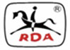

Your Sincerely

Riding for the Disabled Association( NSW) Directors. Riding for the Disabled Association (NSW)

Quad 1, Level 2, 8 Parkview Drive Sydney Olympic Park NSW 2127

(PO Box 710 Sydney Markets NSW 2129) [board@rdansw.org.au](mailto:board@rdansw.org.au)

Ph: (02) 8736 1256

Web: [www.rdansw.org.au](http://www.rdansw.org.au/)

Page **2** of **3**

|  |  |
| --- | --- |
|  |  |
|  |  |
|  |  |



Our Ref: 1086676

26 February 2024

Board of Directors

Riding for the Disabled Association (NSW) "Quad 1" Level 2

8 Parkview Drive

Sydney Olympic Park NSW 2127

|  |
| --- |
| **Email: [Board@rdansw.org.au](mailto:Board@rdansw.org.au)** |
| This document, including any attachments, may contain privileged and confidential information intended only for the addressee named above. If you are not the intended recipient please notify us. Any unauthorised use, distribution or reproduction of the content of this document is expressly forbidden. |

Dear Directors

# Advice regarding funds received by Riding for the Disabled Association (NSW) (RDA NSW) from Racing NSW

1. We refer to your letter dated 19 February 2024 requesting advice in respect of distribution of the sum of $525,000 received from Racing NSW.

# Factual background

1. We understand the key facts to be as follows, and our advice is premised on this understanding:
   1. RDA NSW is a company limited by guarantee that was registered on 12 November 1980.
   2. RDA NSW is governed by a constitution that was adopted on 5 May 2018 (**Constitution**).
   3. The members of RDA NSW (as defined in the Constitution) include 34 centres throughout NSW which provide horse-related therapeutic opportunities and activities for people with disabilities (**Centres**). The Centres are unincorporated groups of individuals.



* 1. In or around November 2023, RDA NSW received a payment of $525,000 (the **Funds**) from Racing NSW. The payment was made to RDA NSW as it was the charity allocated to the winning horse in the Golden Eagle race.
  2. The directors of RDA NSW are uncertain as to whether the Funds can be distributed to the Centres, including as to whether this would be in contravention of the Constitution.

1. For the purpose of this advice, we have assumed that Racing NSW intended for the Funds to be paid to RDA NSW and used for the benefit of the Centres as RDA NSW sees fit. If this assumption is incorrect and Racing NSW in fact paid the Funds on the condition that they were to be used for a specific purpose (e.g. for the benefit of only certain of the Centres or not to be distributed to the Centres at all) then this would have a bearing upon our advice (but we have not seen any documents to this effect). The email from Molly Rose at Racing NSW on 31 October 2023 suggests that RDA NSW (and not a particular Centre) was chosen by Racing NSW as the nominated charity.

# Summary

1. The question you have asked us is essentially whether RDA NSW can distribute the Funds to the Centres or whether there is anything in the Constitution or otherwise that would prevent RDA NSW from doing so.
2. In short, our views are as follows:
   1. By paying the Funds to the Centres as currently comprised, there is a question as to whether RDA NSW is paying the Funds to its "Members". This is because the Centres are unincorporated and are, presumably, comprised of different individuals to those who comprised the Centres at the time of registration of RDA NSW. We have not considered this in any detail given that it does not have a significant bearing on our advice. If you would nonetheless like us to consider this further, please let us know.
   2. If the Centres (as currently comprised) are not "Members" as defined in the Constitution, RDA NSW can distribute the Funds to them provided that such distributions are for the purpose of undertaking or promoting the Objects (as required by clause 6.1 of the Constitution). Given that one of the Objects (as defined in clause 3) is to *"encourage, promote, support and assist [the*

*Centres] to provide equine and equestrian opportunities and activities…for people with disabilities"*, this seems to be readily satisfied.

* 1. If the Centres (as currently comprised) are "Members", then in addition to the requirement in clause 6.1, RDA NSW would also have to ensure that the Funds are distributed in one of the ways set out in clause 6.5 of the Constitution, including (most relevantly):
     1. by way of a grant (i.e. a gift) for the purpose of advancing the Objects (as defined). The grant would need to be approved by the Directors and listed in the annual report and financial statements; or
     2. by way of reimbursement for amounts incurred by the Centres in carrying out RDA NSW's charitable purposes. Again, the reimbursement would need to be approved by the Directors.
  2. Given the uncertain status of the Centres as Members, we suggest that the distributions occur by way of grants, or alternatively reimbursement of costs actually incurred by the Centres (i.e. that you comply with both clauses 6.1 and 6.5). In making the payments we suggest that you explicitly state that the Funds are being advanced for the purpose of encouraging, promoting, supporting and assisting the particular Centre to provide equine and equestrian opportunities for people with disabilities. You may also wish to seek confirmation from the Centres that they will use the Funds for this purpose, before the payments are made.
  3. There is no restriction in the *Corporations Act 2001* (Cth) (**Corporations Act**) preventing RDA NSW from distributing the Funds to the Centres. We have also undertaken a preliminary review of the *Australian Charities and Not-for-profits Commission Act 2012* (Cth) (**ACNC Act**) and have not identified any relevant restrictions.

1. We have not considered the tax implications of distributing the Funds to the Centres.

# Relevant clauses of Constitution

1. The Constitution contains the following relevant clauses (emphasis added):
   1. ***Clause 3***: *"The Company is established to* ***pursue charitable purposes only****. The Company’s Objects are to:*
      1. *Be the governing body in New South Wales for Riding for people with disabilities and be recognized as such by the New South Wales Government;*
      2. *Be and remain the principal New South Wales affiliate option of RDAA or its successor;*
      3. ***Encourage, promote, support and assist Accredited Centres and Provisional Centres and Steering Committees to provide equine and equestrian opportunities and activities as riding therapy (including any other form of therapy which can be performed with the aid of horses), sport, recreation, education and training and safety programs for people with disabilities****;*
      4. *Foster and support the integration of people with disabilities into the activities and into the administration of Accredited Centres, Provisional Centres, Steering Committees and the Company in general;*
      5. *Set and determine standards in the Company’s safety, training, horse management and equine related activities and programmes;*
      6. *Provide or arrange for training, training materials and assessment services for the Company’s employees, coaches and volunteers;*
      7. *Liaise with and manage responsibilities to other organisations, including but not limited to international, national and state organisations (whether such organisations are commercial, charitable or government*

*organisations), that have an interest in the treatment and well-being of people with disabilities;*

* + 1. *Seek to influence all facets of Government, as well as business and the community, to support and finance the activities of the Company and its Members;*
    2. *Pursue, either directly or through other related entities, commercial arrangements, including sponsorship and marketing opportunities, as are appropriate to further these Objects;*
    3. *Promote mutual trust and confidence between the Company and the Members in pursuit of these Objects;*
    4. *Maintain national accreditation as a Registered Training Organisation;*
    5. *Abide by the ASQA and AQTF Standards;*
    6. *Provide and maintain such facilities and equipment as may be required for use by and for the purposes of the Company;*
    7. *Hold and administer property in trust as may be required by and for the purposes of the Objects, Accredited Centres, Provisional Centres and Steering Committees;*
    8. *Act as a co-ordinating body for Members and all Participants in horse related activities for people with disabilities or those who are associated with Accredited Centres, Provisional Centres and Steering Committees, and to provide a forum for the exchange of information and ideas for the betterment of the Company and its Members;*
    9. *Act at all times in the best interests of the Members and all Participants in the activities of the Company;*
    10. *Establish Steering Committees in suitable locations throughout New South Wales to support the Objects of the Company;*
    11. *Develop and deliver nationally accredited and recognised qualifications for coaches and training programs for volunteers;*
    12. *Do all that is necessary, incidental or conducive to the attainment of these Objects and to enable the Members to receive the benefits which these Objects are intended to achieve; and*
    13. *Apply the income and property of the Company solely to promote these Objects."*
  1. ***Clause 6.1***: "*The Company will apply its income and property only in undertaking or promoting the Objects."*
  2. ***Clause 6.2***: *"No portion of the income and property of the Company may be paid or transferred directly or indirectly by way of dividend, bonus or otherwise howsoever to any Member."*
  3. ***Clause 6.5***: *"Nothing in Clause 6.2 prevents the payment or advancement in good faith of:*
     1. *A loan or* ***grant*** *to a Member* ***for the purposes of advancing the Objects****, provided that:*
        1. *The loan or grant is approved by the Directors;*
        2. *A loan agreement, including terms of interest and repayment is signed by both parties;*
        3. *The terms of the loan or grant require that the funds may only be used for a purpose consistent with advancing the Objects;*
        4. *The loan or grant is listed in the annual report and financial statements of the Member and the Company; and*
        5. *In respect of any loan, reasonable and proper interest on money borrowed is applied.*
     2. *An amount to any Member or approved individual in return for any services actually rendered to the Company or for goods supplied in the ordinary and usual course of business upon receipt of a proper tax invoice.*
     3. *Reasonable and proper rent for premises let by any Member or any other party to the Company.*
     4. ***Reimbursement****, as may be approved by Directors,* ***of an amount incurred by a Member*** *and Volunteers of a Centre in carrying out the Company’s charitable purposes."*

# Interpretation of Constitution

*Overview*

1. Our view is that it is clear from the wording of clause 6.5 (in particular the words "*nothing in Clause 6.2 prevents…*") that it takes precedence over clause 6.2 to the extent of any inconsistency.
2. If the Centres (as currently comprised) are "Members" as defined in the Constitution, then RDA NSW can make payments to the Centres if it complies with clauses 6.1 and 6.5 of the Constitution.
3. If the Centres (as currently comprised) are not "Members" as defined in the Constitution, then the RDA NSW would only need to comply with clause 6.1 when distributing the Funds to the Centres.
4. Given the complexities regarding the status of the Centres (as noted above), it would be prudent to comply with both clauses 6.1 and 6.5 in making any payments to the Centres.

*Clause 6.1*

1. **Clause 6.1** requires RDA NSW to apply its income "only in undertaking or promoting the Objects". The most relevant Object appears to be the one in clause 3(a) which is to "encourage, promote, support and assist [Centres] to provide equine and equestrian opportunities and activities as riding therapy (including any other form of therapy which can be performed with the aid of horses), sport, recreation, education and training and safety programs for people with disabilities".
2. If RDA NSW makes it clear to the Centres that the Funds are being advanced for this purpose, we do not see any issues with the requirements of clause 6.1 being satisfied.

*Clause 6.5*

1. Clause 6.5 limits the ways in which payments can be made to Members.
2. ***Clause 6.5(a)***, which allows grants to be made to Members *"for the purpose of advancing the Objects"* appears to be readily satisfied, particularly if RDA NSW makes it clear to the Centres that the Funds are being advanced for the purpose set out in clause 3(a), as suggested above.
3. A "grant" does not have any specific legal meaning so reliance should be placed on the dictionary definition. The Macquarie Dictionary defines a "grant" as "*an amount of money given especially by the government to a person or organization for a special purpose*". Essentially, a grant is a gift tied to a particular purpose, in respect of which there is no need for repayment.
4. The grant would need to be approved by the Directors and listed in the annual report and financial statements (in accordance with the terms of 6.5(a)).
5. Reliance on clause 6.5(a) appears to be the simplest way of paying the Funds to the Centres. Clauses 6.5(b) and (c) do not appear to be as relevant (based on our understanding of the relationship between RDA NSW and the Centres).
6. ***Clause 6.2(d)*** could be relied upon but RDA NSW would need to ensure that it is only paying the Centres amounts that have actually been incurred by the Centres for the purpose of "*carrying out the Company's charitable purposes*". Any such reimbursements would need to be approved by the Directors.
7. "Charitable purpose" is defined in section 12 of the Charities Act 2013 (Cth) as including "the purpose of advancing health", "the purpose of advancing education", "the purpose of advancing social or public welfare", all of which could cover the majority of the Centres' activities (as we understand them).

*Legal effect of constitutional restraints*

1. We note for completeness that even if it was determined that the distribution of the Funds to the Centres did not comply with clauses 6.1 and/or 6.5 of the Constitution (which we think is unlikely), this would not make the payments invalid. This is because of section 125(1) of the Corporations Act, which provides that:

*"If a company has a constitution, it may contain an express restriction on, or prohibition of, the company's exercise of any of its powers. The exercise of a power by the company is not invalid merely because it is contrary to an express restriction or prohibition in the company's constitution".*

1. Notwithstanding the above, if it was found that the payments did not comply with the Constitution, there could be other adverse consequences, such as potentially disentitling the RDA NSW to any applicable tax concessions. We have not considered this further, given our view that the Funds can be paid to the Centres without any breach of the Constitution.
2. Further, the directors of the RDA NSW have obligations as directors under the Corporations Act such as to exercise their duties in good faith in the best interests of the RDA NSW. To this end the directors should, if they decide to distribute some or all of the money to the Centres, consider an appropriate basis for allocating the Funds.

# Relevant legislation

1. Section 254SA of the Corporations Act prevents companies limited by guarantee that were incorporated on or after 28 June 2010, from paying dividends to their members.1
2. Accordingly, given that RDA NSW was incorporated before 28 June 2010, there is nothing in the Corporations Act preventing it from paying dividends to its members.
3. From a preliminary review, there also does not appear to be anything in the ACNC Act preventing the Funds from being distributed to the Centres. Please let us know if you would like us to consider this further.

# Next Steps

1. In summary, our view is that the RDA NSW can permissibly distribute the Funds to the Centres in the ways set out above.

1 Section 254SA was introduced into the Corporations Act by way of the *Corporations Amendment (Corporate Reporting Reform) Act 2010* (Cth) (**amending Act**) , Item 6 of Schedule 1. Section 1510B(1A) of the Corporations Act provides that, "the amendment made by item 6 of Schedule 1 to the amending Act applies in relation to a company limited by guarantee incorporated on or after the commencement of that item." The commencement date was 28 June 2010.

1. Please let us know if you have any queries or if you would like us to elaborate on any aspect of this advice.

Yours faithfully

|  |  |
| --- | --- |
| Image 39 |  |
| **Robert McGregor**  Partner  HWL Ebsworth Lawyers  +61 2 9334 8845  [rmcgregor@hwle.com.au](mailto:rmcgregor@hwle.com.au) | **Claire Walsh**  Special Counsel  HWL Ebsworth Lawyers  +61 2 9334 8988  [cwalsh@hwle.com.au](mailto:cwalsh@hwle.com.au) |

**Motion:** The prize money from the 2023 Golden Eagle be distributed among our full centres with funds put in trust for those centres in administration or recess.

**Rational:** Since first attending the Golden Eagle in 2018 any prize money has always been divided amongst RDA(NSW) Centres as per minuted decisions made by the Board of

Moved: Date: Sec: Date: For: Against: Result

|  |  |  |  |  |  |  |
| --- | --- | --- | --- | --- | --- | --- |
| JP | 16/12/2023 | AB | 16/12/2023 | JP, AB, TL,  CQ, OS | JO | CARRIED |