
RIDING FOR THE DISABLED ASSOCIATION (NSW)

THE PEARL BATCHELOR VOLUNTEER OF THE YEAR AWARD

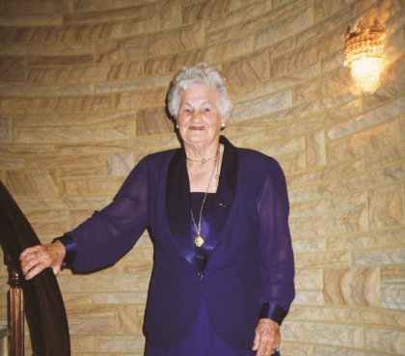

The Pearl Batchelor Volunteer of the Year Award recognises volunteers who demonstrate outstanding and exemplary service to Riding for the Disabled Association (NSW) at Regional and State level.

Award Criteria

- Minimum age of the volunteer must be 18 years at the time of the nomination.
- The volunteer must have been active with their RDA (NSW) Centre for a period of five (5) years or more at the time of the nomination.
- Each Centre may nominate one (1) volunteer each year.
- The nomination must be forwarded to the Regional Rep by 9th February.
- Nominations received after the closing date cannot be accepted under any circumstances.
- The award is presented at the RDA (NSW) Annual General Meeting held in May of the year following the nomination.

Selection Process:

- Each Regional Representative organises a non-RDA (NSW) member of the community to review all nominations for the region and select the winner for the region.
- Each Regional winner is forwarded to the State Office (PO Box 710 Sydney Markets NSW 2129) by 10th of March in the year of the AGM.
- State Office organises a non-RDA (NSW) member of the community to review all regional nominations and select the overall State winner.
- Regional Pearl Batchelor Award winners will be notified before the AGM.
- The recipient of the Pearl Batchelor Award will be notified before the AGM in May and must attend the AGM for the presentation of the award.

THE PEARL BATCHELOR VOLUNTEER OF THE YEAR AWARD

NOMINATION FORM

Name of Nominee:
Address:
Home Phone: |  |  | Mobile:
RDA (NSW) Region: |  |  | RDA Centre: |  |  | Years of Service:
Acknowledgement of Nomination:

I agree to my nomination for the Pearl Batchelor Volunteer of the Year Award and for all information provided and any photo, video, image to be used for publicity of RDA (NSW) for example via FaceBook, web page, media publications.

Name of Nominee:
Signature of Nominee: |  |  |  |  | Date:
Supporting Statement of Nomination:

The Management Committee support this nomination as acknowledgement of the enthusiasm, support and good work the nominee provides our Centre.

Name of Centre President:
Signature of President: |  |  |  |  | Date:

Note:
- Nomination must be accompanied by a colour photograph of the volunteer
- Photograph must be at least 10cm x 15cm

THE PEARL BATCHELOR VOLUNTEER OF THE YEAR AWARD

Supporting Information

Please provide the following information regarding the nominee. Information can be entered in bullet points or free form. Maximum of 500 words
Tell us about this volunteer:  - Their qualities  - Capacities in which they have served your Centre | - Current areas of responsibilities  - How they have enhanced the quality of service for your clients at local, regional and state level

Continue over if required….

